**Affiliation No.:- 531755**

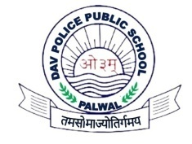 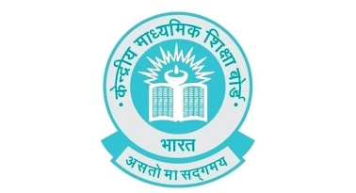 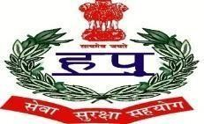

**D.A.V. POLICE PUBLIC SCHOOL**

**NEW POLICE LINES, DELHI-MATHURA HIGHWAY, NH-2,**

**PALWAL, HARYANA-121102**

# PTA Executive Committee

**SESSION (2021-22)**

|  |  |  |  |  |
| --- | --- | --- | --- | --- |
| S.No. | Parent Representattive | Contact No. | Teacher Representative | Contact No. |
| 1. | Mr. Satender | 9350393155 | Ms. Mukti | 9416286052 |
| 2. | Mr. Bijender Gautam | 9671541100 | Ms. Arzoo | 7206187074 |
| 3. | Mr. Aman | 946802162 | Ms. Mamta Yadav | 9899276161 |
| 4. | Mr. Naresh | 9817270515 | Ms. Poonam Sharma | 9306890496 |
| 5. | Mr. Sunil | 9896378578 | Mr. Mohit Paliwal | 9991777269 |
| 6. | Mr. Manoj Kumar | 9812666662 | MS. Bhavna Sharma | 9416636293 |
| 7. | Mr. Satyaveer | 8130045005 | Ms. Poonam Kumari | 9050709064 |
| 8. | Mr. Narveer Singh | 9416406301 | Ms. Hina | 9991123083 |
| 9. | Mrs. Snehlata Hooda | 7827533838 | Ms. Bhawna Vats | 7015928629 |